Energetic Politics
Energy & Government Unit Project for Winter 2015
Project Overview:
Students will role-play in a mock government that is trying to create an energy policy for the United States to follow. Different interest groups will lobby public officials to endorse their industry or political stance in the final policy. Along the way, students will have to run an election campaign, write memorandums, have committee meetings, submit a bill, and do presentations to argue for their industries / opinions. This unit will help students experientially understand the process of government and policy making, while urging them to critically consider the use of energy in this country.
PHASE 1: Elections
One very important part of the political process in our country is the use of elections to choose our government representatives. Though elections seem like they might be a simple and straightforward process, they can actually be very complex and interesting. During an election, candidates are given money by different groups who want the candidate to support policies that will favor their industries or political goals if they are elected. This money is used to “campaign,” where candidates give speeches in different places, buy advertising, pay a staff to help them strategize, and try to get people to vote for them using a variety of strategies.
In this project, students will conduct campaigns to get votes from another class in the school. THE CAMPAIGNS WILL BE FOCUSED ON ENERGY ISSUES! Each group will be assigned a political stance and will be given different amounts of money based on those stances. Students will then create a budget for how to use the money and will spend the money on different advertising and campaign strategies. We will hold an election on Tuesday February, 10 to decide on 2 elected officials.
Instruction Checklist:
- Decide on a candidate from your group
- Discuss what your main message could be to get votes
- Create a basic campaign strategy (answer the 3 big questions & create 2 SMART goals + objectives. See below for details)
- Create a budget for how to spend money (see Price List below)
- Do basic research on why your energy source is best, what its environmental consequences are, etc.
- Create campaign materials
- Create speech for your candidate
- Deliver materials and speech

Teams
Team  Political Stance | Pro-Oil & Coal (Republican) | Pro-Natural Gas & Hydroelectric (Republican) | Pro-Solar, Wind, & Geothermal (Democrat) | Pro-Energy Conservation  (Green Party)
Members | Samuel | JT | Valen | Caleb
 | Stephen | Haley B. | Chloe | Haizlee
 | Kameron | Cesar | Trevon | Haley L.
Money from Industry | $1 million | $400,000 | $400,000 | $50,000
Money from fundraising | $500,000 | $200,000 | $500,000 | $100,000
Money from Party | $250,000 | $250,000 | $500,000 | $10,000
Total | $1.75 million | $850,000 | $1.4 million | $160,000
Campaign Advertising Price List
Item | Price
1 Poster | $50,000
Website | $300,000
Video (per 10 seconds) | $250,000
Presentation (Prezi or Powerpoint) | $60,000
Use of the projector (1 minute) | $100,000
Speech (per 30 seconds) | $50,000
Campaign coaching from teachers  (per 5 minutes) | $200,000
5 Flyers (with photos) | $40,000
5 Flyers (text only) | $30,000
Campaign Strategy Questions
- What is our main message about why our energy policy is best (i.e. why they should vote for you)?
- How does our message compete with the other candidates’ messages?
- What are the most effective ways to get votes using the campaign strategies listed above?
OUR TEAM’S 2 GOALS FOR THIS CAMPAIGN ARE:
- GOAL 1:

  - OBJECTIVE 1:

  - OBJECTIVE 2:

- GOAL 2:

  - OBJECTIVE 1:

  - OBJECTIVE 2:

Basic questions about Energy to research and address in your campaign:
- What are the benefits and drawbacks of using these forms of energy?
- What are the environmental consequences of extracting and using this form?
  - How can you emphasize the positive and downplay the negative consequences in your campaign?
  - How will you answer critical questions about your source’s environmental impacts?
- What are the economic impacts of using this form of energy?
- How is this energy source used in our country?
  - Industry
  - Residential
  - Commercial
Due Dates:
- Thursday, February 5: Strategy / Budget due
- Friday, February 6: Assessment on what you’ve learned about energy and elections
- Monday, February 9: Printed materials due
- Tuesday, February 10: Elections!
PHASE 2: Energy Policy / Bill Creation
Overview:
The United States’ Energy policy is a combination of laws, guidelines, international treaties, and economic incentives or subsidies that govern how energy is used in our country. These policies can have a big impact on what fuels or energy sources our country uses to power itself. Many people are involved in the creation of an Energy Policy. Politicians can propose certain laws or guidelines and can enter into treaties with other countries that restrict pollution and determine energy use in our country. Industries that are affected by the energy policies of the country will “lobby” politicians to favor their industries in the final policy.

Using different energy sources has different environmental impacts on a local, national, and global scale. However, we have to consider impacts on the environment while also considering how easy it is to access energy sources and how expensive or efficient they are to use. Of course, we also have to consider how much energy our country uses and which energy sources can realistically meet that demand. A good Energy Policy takes all of these factors into consideration.

For your reference, below is a pie chart that shows our country’s energy use from 1949-2009.

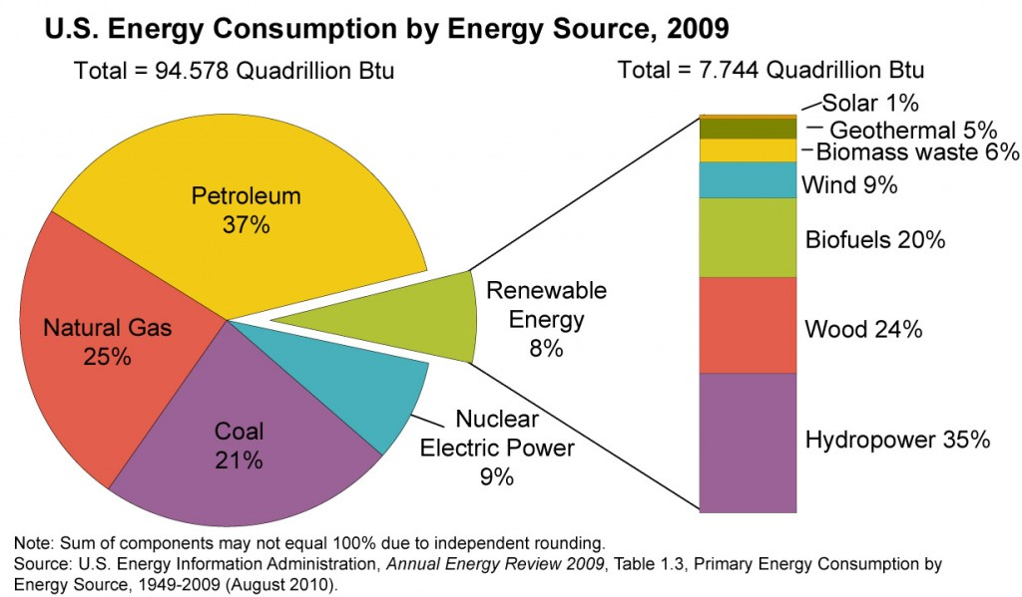

Instructions:
For this phase of the project, students will play a variety of roles. There will be political and business representatives who will take part in the creation of the policy. Below is a breakdown of the roles:

Congresspeople
The 2 winners of the election will become representatives in the US House of Representatives. They will then work together to create an energy policy that is influenced by the businesses that helped get them elected, the lobbyists who present their arguments for their industries, and their own research. They will need to make an argument to the other congresspeople to persuade them to vote for it. The bill will later be submitted to the Senate and the President to see become a law.

Senators
The Senators will vote yes or no on the bill that the Congresspeople submit. 5th grade will play this role.

Chief Justice of the Supreme Court
The Chief Justice will decide whether the bill is “constitutional,” because any laws that are not in line with the constitution are not allowed in this country. Therefore, the Chief Justice will need to know what the constitution says and how far laws are allowed to go in the restriction of freedoms. This role will write an opinion on the bill regarding its constitutionality.

Vice President
The Vice President will serve as an assistant to the President and will do any research requested by the President. They may be involved in talking to congresspeople, sitting in on meetings with the cabinet, and other tasks as assigned by the President.

Secretary of Energy
This role is a cabinet position, appointed by the President. The Secretary of Energy will advise the president and congresspeople on the bill. They are considered to be the experts on energy in the country and can influence the bill during its creation and can recommend to the president whether they should sign it or veto it. They will write a memo to the president on their recommendations about general energy policy and will write an opinion memo about the bill once it is submitted.

Lobbyists
Lobbyists are industry representatives that try to persuade politicians to favor their industry in laws the politicians create in congress. Lobbyists will research different forms of energy and try to persuade the elected officials to include their form of energy in an Energy Policy Bill. Every lobbyist will be assigned one form of energy to support.

Due Dates:
Roles | FRI, February 13 | FRI, February 20 | MON, February 23 | FRI, February 27 | TUES, March 3
Congress-people | Outline of Bill | First Draft of Bill | N/A | Final Draft of Bill | N/A
Chief Justice | Summary of constitutionality research (bullet points) | First Draft of summary of constitutional research (paragraph form) | Final Draft of summary of constitutional research (paragraph form) | N/A | Opinion on constitutionality of the bill
Vice President | Outline of research on general energy policy | Assignments given by the President | Assignments given by the President | Assignments given by the President | Assignments given by the President
Secretary of Energy | Outline of research on general energy policy | First Draft of Memo to President on general policy recommenda-tions | Final Draft of Memo | N/A | Opinion memo on the bill for the President
Lobbyists | Outline of Memo | First Draft of Memo | Final Draft of Memo | N/A | N/A

Research Checklist:
IF YOU ARE A LOBBYIST, YOU WILL BE RESEARCHING ONE FORM OF ENERGY. IF YOU ARE A POLITICIAN, YOUR RESEARCH WILL BE MORE GENERAL AND WILL INCLUDE MANY FORMS OF ENERGY. Use this checklist as a guide for your research and memos.

- Research the positive and negative impacts of using your form of energy by answering these questions:
  - How is your energy source obtained and what are the environmental consequences of this process? (mining, panels, drilling, fracking, etc?)
  - How efficient is your form of energy?
  - When we use your source to create energy, what are the environmental consequences?
  - How expensive is it to obtain and use your type of energy?
  - How much of your type of energy source is available in the United States?
  - How are you going to convince a public official that they should include this type of energy in their policy?
- List all of your sources on a “Works Cited” page (Format to be provided by Julie)
- Outline your memorandums using the answers to your research questions (due Friday, February 13). Include the following in your memo:
  - What the benefits of your industry are to the environment and / or economy
  - Why your energy source is better than other energy sources
  - How much energy your industry could generate if given help from the government
- Write first draft of memo. At least 500 words. Must cite research! (due Friday, February 20)
- Make edits suggested by peers. Turn in final draft. (due Monday, February 23)

Good Resources to Start Your Research:
http://alternativeenergy.procon.org/
http://energy.gov/
http://www.eia.gov/totalenergy/data/annual/index.cfm
http://www.epa.gov/climatechange/
http://en.wikipedia.org/wiki/Energy_policy_of_the_United_States

Roles
President | Julie
Congresspeople | Chloe  Caleb
Chief Justice | Valen
Vice President | Haizlee
Secretary of Energy | Stephen
Lobbyists | Trevon  Kameron  Haley B.  Haley L.  JT  Samuel  Cesar

